A Project Report

on

**AUCTION MANAGEMENT SYSTEM**

Submitted in partial fulfillment of requirements for the award of the course

of

**EGB1201 – JAVA PROGRAMMING**

Under the guidance of

### Ms. Hema R., M.E.,

### Assistant Professor / Information Technology

Submitted By



**TAMILARASU M A (2303811710621111)**

**DEPARTMENT OF ELECTRONICS AND COMMUNICATION ENGINEERING**

**K. RAMAKRISHNAN COLLEGE OF TECHNOLOGY**

(Autonomous)

**TRICHY - 621112**

DECEMBER 2024

**K. RAMAKRISHNAN COLLEGE OF TECHNOLOGY**

**(Autonomous Institution affiliated to Anna University, Chennai)**

# TRICHY - 621112

**BONAFIDE CERTIFICATE**

Certified that this project report on **“AUCTION MANAGEMENT SYSTEM”** is the Bonafide work of **TAMILARASU M A (2303811710621111)** who carried out the project work during the academic year 2024 - 2025 under my supervision.

|  |  |
| --- | --- |
| Signature | Signature |
| **Ms. HEMA R., M.E.,** | **Dr. SYEDAKBAR S., M.E.,Ph.D.,** |
| **SUPERVISOR,** | **HEAD OF THE DEPARTMENT,** |
| Department of Information Technology, | Department of ECE, |
| K. Ramakrishnan College of Technology, | K. Ramakrishnan College of Technology, |
| Trichy - 621112 | Trichy - 621112 |



**DEPARTMENT OF ELECTRONICS AND COMMUNICATION ENGINEERING**

**VISION OF THE INSTITUTION**

             To emerge as a leader among the top institutions in the field of technical education

**MISSION OF THE INSTITUTION**

* Produce smart technocrats with empirical knowledge who can surmount the global challenges
* Create a diverse, fully-engaged, learner-centric campus environment to provide quality education to the students
* Maintain mutually beneficial partnerships with our alumni, industry, and Professional associations

**VISION OF THE DEPARTMENT**

  To create innovative and socially responsible Electronics and Communication Engineers with design skills and research focus to meet Societal and Industrial needs.

**MISSION OF THE DEPARTMENT**

* M1:  To provide high quality education and professional ethics to students through enhanced learning environment
* M2:  To impart a creative environment towards centre of excellence in department with design skill and exposure for research.
* M3:  To nurture required employable skills of students to satisfy the industry and social needs with ethical and human values.

**PROGRAM EDUCATIONAL OBJECTIVES (PEOS)**

* PEO1: Core Knowledge Development: Graduates will have enhanced engineering skills in the field of electronics, communication and interdisciplinary areas to serve the society with global standards.
* PEO2: Professional development: Graduates will apply the technical knowledge for continuous up gradation of their professional skills to become an inimitable employee, researcher or entrepreneur.
* PEO3: Analytical Thinking: Graduates will have analytic and thinking skills to provide the innovative solutions for industry and societal requirements.

**PROGRAM OUTCOMES**

Engineering students will be able to:

1. **Engineering knowledge:** Apply the knowledge of mathematics, science, engineering fundamentals, and an engineering specialization to the solution of complex engineering problems.
2. **Problem analysis:** Identify, formulate, review research literature, and analyze complex engineering problems reaching substantiated conclusions using first principles of mathematics, natural sciences, and engineering sciences.
3. **Design/development of solutions:** Design solutions for complex engineering problems and design system components or processes that meet the specified needs with appropriate consideration for the public health and safety, and the cultural, societal, and environmental considerations.
4. **Conduct investigations of complex problems:** Use research-based knowledge and research methods including design of experiments, analysis and interpretation of data, and synthesis of the information to provide valid conclusions.
5. **Modern tool usage:** Create, select, and apply appropriate techniques, resources, and modern engineering and IT tools including prediction and modelling to complex engineering activities with an understanding of the limitations.
6. **The engineer and society:** Apply reasoning informed by the contextual knowledge to assess societal, health, safety, legal and cultural issues and the consequent responsibilities relevant to the professional engineering practice.
7. **Environment and sustainability:** Understand the impact of the professional engineering solutions in societal and environmental contexts, and demonstrate the knowledge of, and need for sustainable development.
8. **Ethics:** Apply ethical principles and commit to professional ethics and responsibilities and norms of the engineering practice.
9. **Individual and team work:** Function effectively as an individual, and as a member or leader in diverse teams, and in multidisciplinary settings.
10. **Communication:** Communicate effectively on complex engineering activities with the engineering community and with society at large, such as, being able to comprehend and write effective reports and design documentation, make effective presentations, and give and receive clear instructions.
11. **Project management and finance:** Demonstrate knowledge and understanding of the engineering and management principles and apply these to one’s own work, as a member and leader in a team, to manage projects and in multidisciplinary environments.
12. **Life-long learning:** Recognize the need for, and have the preparation and ability to engage in independent and life-long learning in the broadest context of technological change.

**PROGRAM SPECIFIC OUTCOMES (PSOs)**

* PSO1: To analyse, design and develop solutions by applying foundational concepts of electronics and communication engineering.
* PSO2:   To apply design principles and best practices for developing quality products for scientific and business applications.

# 

# ABSTRACT

# An Auction Management System is a digital platform designed to streamline the process of organizing, conducting, and managing auctions. It replaces traditional manual methods with an efficient, user-friendly, and transparent system that caters to buyers, sellers, and administrators. The system ensures a secure and seamless experience by integrating advanced technologies like real-time bidding, data encryption, and automated notifications.

# The primary objective of this system is to provide an interactive and intuitive interface that allows users to participate in auctions from any location. The platform supports different types of auctions, including English auctions, Dutch auctions, and sealed-bid auctions, offering flexibility to sellers in choosing the format that best suits their needs. Registered sellers can list their items with detailed descriptions, images, and base prices, while buyers can place bids dynamically and monitor the auction's progress in real time.

# Key features include user registration and authentication, item listing management, bid tracking, payment integration, and report generation.

# ABSTRACT WITH POs AND PSOs MAPPING

|  |  |  |
| --- | --- | --- |
| **ABSTRACT** | **POs MAPPED** | **PSOs MAPPED** |
| An **Auction Management System** is a digital platform designed to streamline the process of organizing, conducting, and managing auctions. It replaces traditional manual methods with an efficient, user-friendly, and transparent system that caters to buyers, sellers, and administrators. The system ensures a secure and seamless experience by integrating advanced technologies like real-time bidding, data encryption, and automated notifications. | **PO1,**  **PO2,**  **PO3,**  **PO5,**  **PO9,**  **PO10** | **PSO1,**  **PSO2** |

Note: 1- Low, 2-Medium, 3- High

**SUPERVISOR HEAD OF THE DEPARTMENT**

# 

# TABLE OF CONTENTS

|  |  |  |
| --- | --- | --- |
| **CHAPTER** No. | TITLE | **PAGE** No. |
|  | ABSTRACT |  |
| 1 | INTRODUCTION |  |
|  | 1.1 Objective | 1 |
|  | 1.2 Overview | 1 |
|  | 1.3 Java Programming concepts | 2 |
| 2 | PROJECT METHODOLOGY |  |
|  | 2.1 Proposed Work | 3 |
|  | 2.2 Block Diagram | 3 |
| 3 | MODULE DESCRIPTION |  |
|  | 3.1 User Interface (UI) Module | 4 |
|  | 3.2 Item Management System | 4 |
|  | 3.3 Bid Management Module | 5 |
|  | 3.4 Real Time Update Module | 5 |
|  | 3.5 Auction Summary Module | 5 |
| 4 | RESULTS AND DISCUSSION | 6 |
| 5 | CONCLUSION | 7 |
|  | REFERENCES | 8 |
|  | APPENDIX | 9 |

# CHAPTER 1

# INTRODUCTION

# Objective

# The primary objective of the Auction Management System is to design and implement a user-friendly, interactive platform that facilitates the management of auctions. This includes functionalities for adding auction items, placing bids, and displaying auction details, ensuring a seamless experience for users. The system leverages Java Swing and AWT to provide a graphical user interface (GUI) that demonstrates efficient event-driven programming, data validation, and real-time updates, fostering practical skills in object-oriented software development.

# Overview

# An Auction Management System is a software application designed to facilitate and manage the operations of an auction. It serves as a platform where items can be listed for bidding, users can place bids, and the highest bidder is determined in a structured and automated way. Such systems streamline the auction process, ensuring transparency, accuracy, and efficiency.

# 1

* 1. **Java Programming Concepts**
     1. **Object-Oriented Programming (OOPs):**
* Classes and Objects: To represent entities like Expenses, Users, and

Categories.

* Polymorphism: To handle different types of expenses (fixed vs. variable) or display different reports.
* Inheritance: For reusing and extending functionalities

**1.3.2 Java AWT:**

* Labels (Label): Used to display static text such as "Item Name," "Base Price," or "Highest Bidder."
* Text Fields (TextField): Enable users to input data, such as item details, bidder names, or bid amounts.
* Buttons (Button): Allow users to perform actions, such as adding items, placing bids, or closing the auction.

**1.3.3 Java Swing:**

* Java Swing provides a wide range of prebuilt components, such as buttons, text fields, labels, combo boxes, and tables, that can be customized for the auction interface.
* Supports interactive functionality through event listeners and handlers.
* Java Swing allows separating functionalities into smaller components, making the system easier to manage and debug.

2

# CHAPTER 2

# PROJECT METHODOLOGY

**2.1 Proposed Work**

The proposed work outlines a structured approach to designing and implementing an Auction Management System using Java's AWT (Abstract Window Toolkit) and Swing for graphical user interface (GUI) development. The system will facilitate the seamless management of auction items, bidders, and bidding processes while ensuring user-friendly interaction.

* To develop a GUI-based system for managing auctions using Java Swing and AWT.
* To allow sellers to add items for auction with relevant details such as name and base price.
* To enable bidders to place bids interactively and track the highest bid in real-time.

**2.2 Block Diagram**

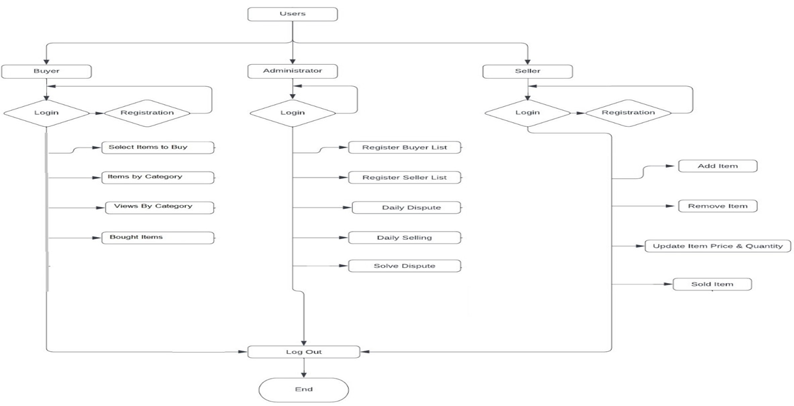

3

# CHAPTER 3

# MODULE DESCRIPTION

## 3.1 User Interface (UI) Module

## Purpose: This module provides a graphical interface for users to interact with the system.

## Components:

## AWT Components: Used for basic window layouts and controls (e.g., panels, buttons, labels).

## Swing Components: Advanced GUI components like JFrame, JPanel, JButton, JTextField, JLabel, JList, and JTable are used for a modern look and feel.

## 3.2 Item Management Module

## Purpose: Handles the addition and management of auction items.

## Components:

## A form for adding items with fields like item name, description, and base price.

## Data validation to ensure all fields are correctly filled.

## 3.3 Bid Management Module

## Purpose: Manages bidding operations, including bid placement and validation.

## Components:

## Allows users to select an item and place a bid through a user-friendly interface.

## Validates that the bid is higher than the current highest bid.

## Updates the item details dynamically with the highest bid and bidder information.

## 3.4 Real-Time Update Module

## Purpose: Ensures real-time updates of bid information across the interface.

## Components:

## Dynamically updates the display when a new bid is placed.

## Notifies users if a bid is successful or if it does not meet the bidding criteria.

## 3.5 Auction Summary Module

## Purpose: Displays a summary of auction results and generates reports if needed.

## Components:

## Shows the highest bidder and bid amount for each item.

## Option to view all bids placed for an item in a detailed table.

## Provides options to save auction results to a file (optional).

# CHAPTER 4

# RESULTS AND DISCUSSION

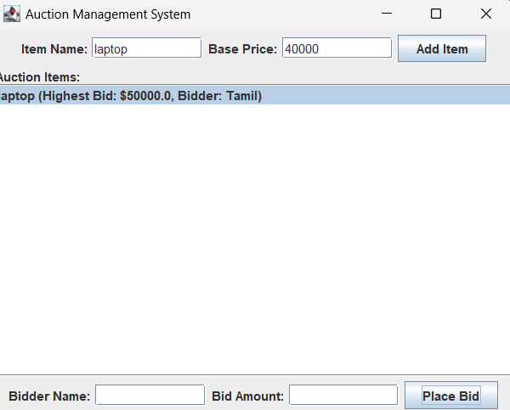

6

# CHAPTER 5

# CONCLUSION

The Auction Management System implemented in Java using AWT and Swing demonstrates the power and flexibility of Java for creating interactive and user-friendly desktop applications. By leveraging the robust GUI components provided by Swing and the layout management capabilities of AWT, the system successfully manages auction operations such as adding items, placing bids, and displaying results in real time.

This project highlights the importance of combining core programming principles with intuitive design to deliver efficient, scalable, and maintainable solutions. The system ensures transparency, accuracy, and ease of use, making it suitable for real-world applications. Furthermore, it serves as a foundational step for more advanced auction platforms that can integrate features like database storage, network-based bidding, or analytics.

Overall, the Auction Management System is a practical demonstration of Java’s capabilities in solving real-world problems through interactive and dynamic software applications. It is a valuable project for enhancing programming and software design skills.

**REFERENCES**

* Oracle Java Documentation: <https://docs.oracle.com/javase/>
* Herbert Schildt, *Java: The Complete Reference*, Oracle Press
* Cay S. Horstmann, *Core Java Volume I – Fundamentals*, Pearson Education
* Kathy Sierra, Bert Bates, *Head First Java*, O'Reilly Media

**APPENDIX**

**(Coding)**

import javax.swing.*;

import java.awt.*;

import java.awt.event.ActionEvent;

import java.awt.event.ActionListener;

import java.util.ArrayList;

class AuctionItem {

String name;

double basePrice;

double highestBid;

String highestBidder;

AuctionItem(String name, double basePrice) {

this.name = name;

this.basePrice = basePrice;

this.highestBid = basePrice;

this.highestBidder = "None";

}

void placeBid(String bidder, double bid) {

if (bid > highestBid) {

highestBid = bid;

highestBidder = bidder;

}

}

}

public class AuctionManagementSystem {

private JFrame frame;

private ArrayList<AuctionItem> items;

private DefaultListModel<String> itemListModel;

public AuctionManagementSystem() {

items = new ArrayList<>();

itemListModel = new DefaultListModel<>();

initialize();

}

private void initialize() {

frame = new JFrame("Auction Management System");

frame.setDefaultCloseOperation(JFrame.EXIT_ON_CLOSE);

frame.setSize(500, 400);

frame.setLayout(new BorderLayout());

// Top panel for adding items

JPanel addItemPanel = new JPanel(new FlowLayout());

JLabel itemNameLabel = new JLabel("Item Name:");

JTextField itemNameField = new JTextField(10);

JLabel basePriceLabel = new JLabel("Base Price:");

JTextField basePriceField = new JTextField(10);

JButton addItemButton = new JButton("Add Item");

addItemPanel.add(itemNameLabel);

addItemPanel.add(itemNameField);

addItemPanel.add(basePriceLabel);

addItemPanel.add(basePriceField);

addItemPanel.add(addItemButton);

// Center panel for displaying items

JPanel centerPanel = new JPanel(new BorderLayout());

JList<String> itemList = new JList<>(itemListModel);

JScrollPane scrollPane = new JScrollPane(itemList);

centerPanel.add(new JLabel("Auction Items:"), BorderLayout.NORTH);

centerPanel.add(scrollPane, BorderLayout.CENTER);

// Bottom panel for placing bids

JPanel bidPanel = new JPanel(new FlowLayout());

JLabel bidderLabel = new JLabel("Bidder Name:");

JTextField bidderField = new JTextField(10);

JLabel bidLabel = new JLabel("Bid Amount:");

JTextField bidField = new JTextField(10);

JButton placeBidButton = new JButton("Place Bid");

bidPanel.add(bidderLabel);

bidPanel.add(bidderField);

bidPanel.add(bidLabel);

bidPanel.add(bidField);

bidPanel.add(placeBidButton);

// Add panels to the frame

frame.add(addItemPanel, BorderLayout.NORTH);

frame.add(centerPanel, BorderLayout.CENTER);

frame.add(bidPanel, BorderLayout.SOUTH);

// Action listeners

addItemButton.addActionListener(new ActionListener() {

@Override

public void actionPerformed(ActionEvent e) {

String name = itemNameField.getText();

String basePriceText = basePriceField.getText();

if (name.isEmpty() || basePriceText.isEmpty()) {

JOptionPane.showMessageDialog(frame, "Please fill in all fields.", "Error", JOptionPane.ERROR_MESSAGE);

return;

}

try {

double basePrice = Double.parseDouble(basePriceText);

AuctionItem item = new AuctionItem(name, basePrice);

items.add(item);

itemListModel.addElement(item.name + " (Base Price: $" + basePrice + ")");

itemNameField.setText("");

basePriceField.setText("");

} catch (NumberFormatException ex) {

JOptionPane.showMessageDialog(frame, "Invalid base price.", "Error", JOptionPane.ERROR_MESSAGE);

}

}

});

placeBidButton.addActionListener(new ActionListener() {

@Override

public void actionPerformed(ActionEvent e) {

int selectedIndex = itemList.getSelectedIndex();

if (selectedIndex == -1) {

JOptionPane.showMessageDialog(frame, "Please select an item to bid on.", "Error", JOptionPane.ERROR_MESSAGE);

return;

}

String bidder = bidderField.getText();

String bidText = bidField.getText();

if (bidder.isEmpty() || bidText.isEmpty()) {

JOptionPane.showMessageDialog(frame, "Please fill in all fields.", "Error", JOptionPane.ERROR_MESSAGE);

return;

}

try {

double bid = Double.parseDouble(bidText);

AuctionItem selectedItem = items.get(selectedIndex);

if (bid > selectedItem.highestBid) {

selectedItem.placeBid(bidder, bid);

itemListModel.set(selectedIndex, selectedItem.name + " (Highest Bid: $" + bid + ", Bidder: " + bidder + ")");

bidderField.setText("");

bidField.setText("");

} else {

JOptionPane.showMessageDialog(frame, "Bid must be higher than the current highest bid.", "Error", JOptionPane.ERROR_MESSAGE);

}

} catch (NumberFormatException ex) {

JOptionPane.showMessageDialog(frame, "Invalid bid amount.", "Error", JOptionPane.ERROR_MESSAGE);

}

}

});

frame.setVisible(true);

}

public static void main(String[] args) {

SwingUtilities.invokeLater(AuctionManagementSystem::new);

}

}